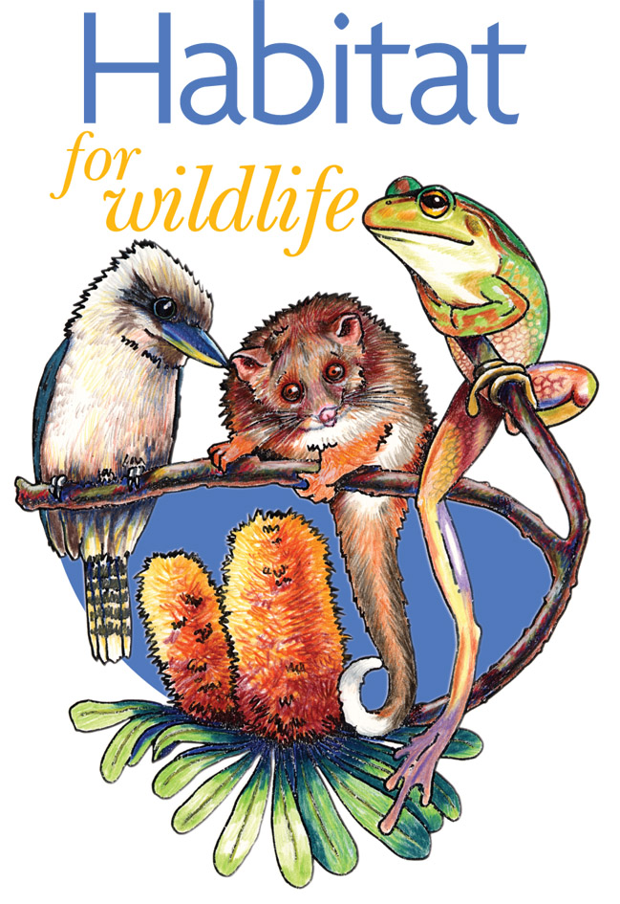

HABITAT FOR WILDLIFE

Office Use Only

Member HW____ /_____
Folder Yes / No
Sign Yes / No
Plants Yes / No
Joined from:
Urban and semi rural properties under ½ hectare (5000m²)
*Properties with over ½ hectare or more of native bushland
- use Land for Wildlife form

For more information Phone: 43494756 or Website: cen.org.au

MEMBERSHIP FORM

PLEASE PRINT IN BLOCK LETTERS
 | First Name(s) Surname(s)
 | Property address  Postcode |  |  |  |  |  |  |  |  |  |  |  |  |  |  |  | Postal address (if different)  Postcode
 | Phone (H) |  |  |  |  |  |  |  |  |  |  |  |  |  |  |  | Mobile
 | E-mail address
 | - I would like to be emailed invitations to Community Environment Events, workshops & Field days.

Commitment to Habitat for Wildlife

I/we agree to become a member of Habitat for Wildlife.
As a member of Habitat for Wildlife I/we will endeavour to encourage native wildlife into our backyard by providing suitable shelter, natural foods and water.
I/we will endeavour to ensure that our native wildlife is safe from pets and invasive plants.
I/we understand that the Community Environment Network will supply available information and run workshops and activities on habitat issues from time to time.

Signed ___________________________________ Dated ____________________________



Return form to:
PO Box 149 Ourimbah 2258 or via email: habitatforwildlife@cen.org.au

For more information Phone: 43494756 or Website: cen.org.au

Habitat for Wildlife is a program of the Community Environment Network

